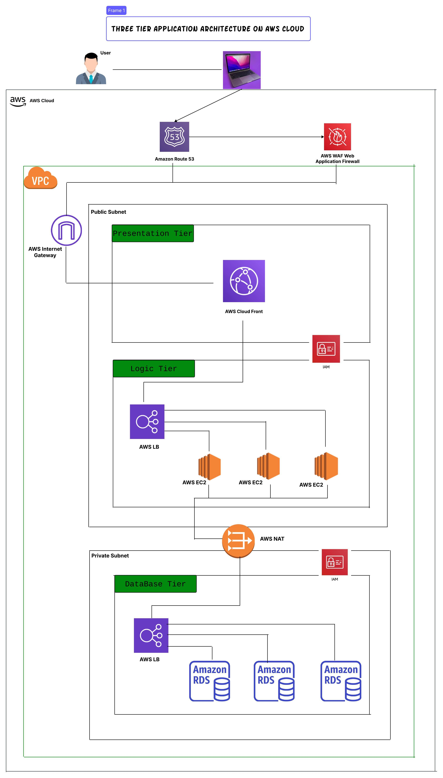
Explanation of the Three-Tier Application Architecture on AWS Cloud
This diagram represents a Three-Tier Architecture deployed on AWS Cloud, which is a standard software architecture pattern used in web applications. The architecture consists of three distinct layers:
- Presentation Tier (Frontend)
- Logic Tier (Backend)
- Database Tier
Each tier is deployed in AWS Cloud and designed for scalability, security, and performance.

1. Presentation Tier (Frontend)
- This tier interacts with the user.
- The request first goes through Amazon Route 53, which is a DNS service to route user traffic.
- A Web Application Firewall (AWS WAF) protects the application from common attacks.
- The application frontend is hosted using AWS CloudFront, which is a CDN (Content Delivery Network) that helps in caching and reducing latency.
- This tier resides in the Public Subnet.

2. Logic Tier (Backend)
- This is the application processing layer where business logic is executed.
- The requests from the frontend are sent to an AWS Load Balancer (AWS LB), which distributes traffic to multiple EC2 instances (Elastic Compute Cloud).
- Multiple AWS EC2 instances handle the business logic and ensure high availability.
- AWS Identity and Access Management (IAM) is used to manage access controls.
- The AWS NAT Gateway allows secure communication between the logic tier and other AWS services without exposing resources to the public internet.

3. Database Tier
- This is the data storage layer where user and application data is stored.
- It resides in a Private Subnet for security.
- The database service is hosted using Amazon RDS (Relational Database Service), which provides managed databases such as MySQL, PostgreSQL, or Aurora.
- A Load Balancer (AWS LB) is also used to distribute database queries efficiently.

Advantages of This Architecture
- Scalability: Each layer can be scaled independently.
- Security: Database is in a private subnet, and AWS WAF protects against threats.
- Availability: Load balancers and multiple EC2 instances ensure high availability.
- Performance: CloudFront and Route 53 improve performance by reducing latency.

Interview Questions & Answers

Basic Questions
- What is a Three-Tier Architecture?
  - A three-tier architecture consists of the Presentation Tier (UI), Logic Tier (Backend), and Database Tier. It separates concerns, improves scalability, and enhances security.
- Why is AWS Route 53 used?
  - AWS Route 53 is a DNS (Domain Name System) service that helps route user requests to different AWS resources.
- What is AWS WAF, and why is it used?
  - AWS Web Application Firewall (WAF) helps protect the application from threats like SQL injection, cross-site scripting (XSS), and DDoS attacks.
- How does AWS CloudFront improve performance?
  - AWS CloudFront is a Content Delivery Network (CDN) that caches content at edge locations, reducing latency and improving speed.

Intermediate Questions
- What is the role of a Load Balancer in this architecture?
  - AWS Load Balancer distributes incoming traffic across multiple EC2 instances to ensure availability and reliability.
- Why are EC2 instances used in the Logic Tier?
  - EC2 instances execute the application logic, handle API calls, and process user requests.
- Why do we use AWS NAT Gateway?
  - NAT Gateway allows private instances (like the database tier) to access the internet securely without exposing them to the public.

Advanced Questions
- Why is the Database Tier placed in a private subnet?
  - A private subnet prevents direct internet access, enhancing security by restricting access to only the application layer.
- How can we scale this architecture?
  - Frontend Scaling: Using AWS CloudFront and Auto Scaling for the UI.
  - Backend Scaling: Auto Scaling for EC2 instances, using containers (ECS, EKS).
  - Database Scaling: Read replicas, Multi-AZ RDS deployment.
- What happens if an EC2 instance fails?
  - The Load Balancer redirects traffic to healthy instances, ensuring continuous operation.

Key AWS Services in the Architecture
- Networking Components:
  - VPC (Virtual Private Cloud) for network isolation.
  - Public Subnets: Hosts AWS CloudFront (Presentation Tier) and Application Load Balancer, 3 EC2 Instances (Logic Tier).
  - Private Subnets: Hosts AWS Load Balancer, 3 Amazon RDS instances (Database Tier).
  - Internet Gateway (IGW) for internet access.
  - NAT Gateway for private instances to access the internet securely.
  - Network ACLs (NACLs) instead of Security Groups to control inbound/outbound traffic.
- Security & Access Control:
  - AWS WAF (Web Application Firewall) for protection.
  - IAM Roles & Policies for secure access.
  - Network ACLs (NACLs) to manage traffic control at the subnet level.
- Frontend Layer (Presentation Tier - Public Subnet):
  - Amazon Route 53 (Domain Name System for global routing).
  - AWS CloudFront (Content Delivery Network to optimize content delivery).
- Application Layer (Logic Tier - Public Subnet):
  - Application Load Balancer (ALB) to distribute traffic.
  - 3 EC2 Instances for processing application logic.
  - IAM configured for secure access.
- Database Layer (Data Tier - Private Subnet):
  - AWS Load Balancer (Optional for HA).
  - 3 Amazon RDS Instances.
  - IAM configured for secure database access.

1. provider.tf - AWS Provider
provider "aws" {
region = var.aws_region
}

2. variables.tf - Define Input Variables
variable "aws_region" {
description = "AWS Region"
default = "us-east-1"
}

variable "vpc_cidr" {
description = "VPC CIDR Block"
default = "10.0.0.0/16"
}

variable "public_subnet_cidrs" {
type = list(string)
default = ["10.0.1.0/24", "10.0.2.0/24", "10.0.3.0/24"]
}

variable "private_subnet_cidrs" {
type = list(string)
default = ["10.0.4.0/24", "10.0.5.0/24", "10.0.6.0/24"]
}

3. main.tf - Define AWS Infrastructure
# Create VPC
resource "aws_vpc" "main" {
cidr_block = var.vpc_cidr
}

# Internet Gateway
resource "aws_internet_gateway" "igw" {
vpc_id = aws_vpc.main.id
}

# NAT Gateway
resource "aws_eip" "nat_eip" {
domain = "vpc"
}

resource "aws_nat_gateway" "nat" {
allocation_id = aws_eip.nat_eip.id
subnet_id = aws_subnet.public[0].id
}

# Create Public Subnets
resource "aws_subnet" "public" {
count = 3
vpc_id = aws_vpc.main.id
cidr_block = var.public_subnet_cidrs[count.index]
map_public_ip_on_launch = true
}

# Create Private Subnets
resource "aws_subnet" "private" {
count = 3
vpc_id = aws_vpc.main.id
cidr_block = var.private_subnet_cidrs[count.index]
}

4. AWS Security Configuration (WAF, IAM, NACLs)
# AWS WAF Web Application Firewall
resource "aws_waf_web_acl" "waf" {
name = "my-waf-acl"
metric_name = "myWAFMetric"
default_action {
type = "ALLOW"
}
}

# IAM Role for EC2 Instances
resource "aws_iam_role" "ec2_role" {
name = "EC2Role"
}

# IAM Role for RDS
resource "aws_iam_role" "rds_role" {
name = "RDSRole"
}

# Network ACLs for Public and Private Subnets
resource "aws_network_acl" "public_nacl" {
vpc_id = aws_vpc.main.id
}

resource "aws_network_acl" "private_nacl" {
vpc_id = aws_vpc.main.id
}

5. Deploy AWS CloudFront, EC2, and RDS
# AWS CloudFront Configuration
resource "aws_cloudfront_distribution" "cdn" {
origin {
domain_name = aws_lb.app_lb.dns_name
origin_id = "myALB"
}
}

# Public Web Servers (3 EC2 Instances - Presentation Tier)
resource "aws_instance" "web_server" {
count = 3
ami = "ami-0c55b159cbfafe1f0"
instance_type = "t2.micro"
subnet_id = aws_subnet.public[count.index].id
}

# Private Backend Servers (3 EC2 Instances - Logic Tier)
resource "aws_instance" "app_server" {
count = 3
ami = "ami-0c55b159cbfafe1f0"
instance_type = "t2.micro"
subnet_id = aws_subnet.private[count.index].id
}

# Deploy RDS Database (Only in Private Subnet)
resource "aws_db_instance" "db" {
count = 3
identifier = "rds-instance-${count.index}"
allocated_storage = 20
instance_class = "db.t2.micro"
engine = "mysql"
}

6. Outputs
output "vpc_id" {
value = aws_vpc.main.id
}

output "cloudfront_url" {
value = aws_cloudfront_distribution.cdn.domain_name
}

Final Fixes & Enhancements
✅ AWS CloudFront added and linked to Application Load Balancer.
✅ AWS WAF Web Application Firewall added.
✅ IAM Role for EC2 and RDS instances added.
✅ Network ACLs implemented instead of Security Groups.
✅ 3 EC2 instances in Public Subnets (Presentation Tier).
✅ 3 EC2 instances in Private Subnets (Logic Tier).
✅ 3 RDS instances in Private Subnets (Database Tier).
✅ NAT Gateway configured between Public and Private Subnets.
✅ Outputs now include CloudFront URL.

Now, This is the FINAL Terraform Code Matching Your Architecture with All Security Services and NACLs! 🚀

